 |  | 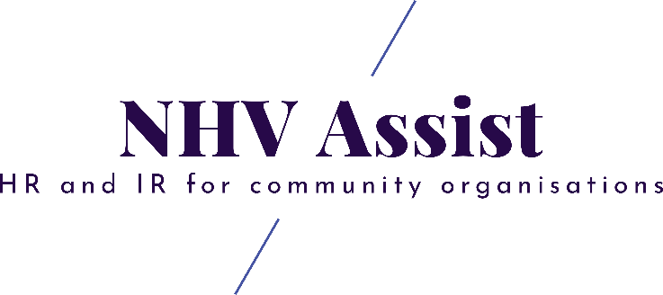
NHV Assist Limited
Phone  Website  Email  ABN | XXX XXX XXX  nhvassist.com  info@nhvassist.com  84637289162

New Employee Hire Form

Instructions

For Employees

Please complete PART A of this form and return to your manager along with other employment paperwork provided, prior to your commencement.

PART A - EMPLOYEE TO COMPLETE
Personal Details
Title: [Fill in title]
Surname: [Fill in surname]
First name: [Fill in first name]
Middle name: [Fill in middle name]
Preferred name: [fill in preferred name]
Date of Birth: DD/MM/YYY
Personal Email Address: | [Fill in personal email address]
Email address for Payslip to be sent to: | [Fill in preferred email address]
Have you worked for [name of organisation] before? | YES ☐ NO ☐
Are you Aboriginal or Torres Strait Islander? | YES ☐ NO ☐

Right to work in Australia
If you are an Australian Citizen, please provide either a:
- Copy of your Australian passport ID page
- Copy of your Australian Citizen certificate
- Copy of your Birth Certificate
If you are a non-Australian Citizen, please provide all the following:
- Copy of your Passport ID Page
- Copy of your Australian Visa Label

Address and Phone Contact Details
Address: [Fill in address]  Suburb: [Fill in suburb] | State: [Fill in state]  Postcode: [Fill in postcode]
Home Phone: [Fill in number] | Mobile Phone: [Fill in mobile phone]

Emergency Contact (must be complete)
Emergency Contact Name: | [Fill in full name]
Emergency Contact Relationship: | [Fill in relationship]
Emergency Contact Number 1: | [Fill in phone number]
Emergency Contact Number 2: | [Fill in phone number]
Primary Bank Account Details
Name of Bank: | [Fill in name of bank]
BSB Number: | [Fill in BSB number]
Account Number: | [Fill in account number]

